Professor Asso. Professor Asst. Professor

Permanent Temporary/Guest

- (Please fill the applications Only in Capital Letter (English) and in clear handwriting.
1 | Name: | Dr. PUMMY KUMARI |  |  |  |  |  | 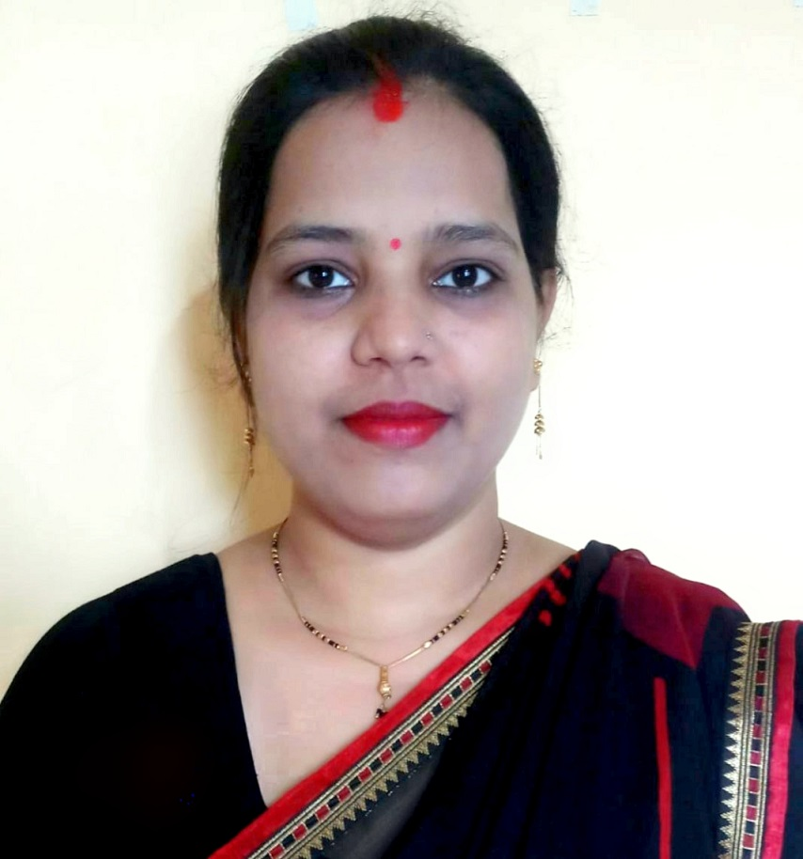  Color Photo
2 | Father’s/Husband Name | BHOLA SHANKAR SINGH
3 | Date of Birth | 12-01-1991
4 | Blood Group | O +
5 | Date of joining in College | 11-05-2023 | Date of Joining  As Teacher |  |  |  | 11-05-2023
6 | Designation | ASSISTANT PROFESSOR (G.F.)
7 | Department | SOCIOLOGY
8 | Aadhar Number | 212691953904 |  | Pan No. |  |  |  | ETWPK3509R
9 | Specialization | SOCIAL ANTHROPOLOGY
10 | Education Pursuit/Highest Qualification | Ph.D.
11 | PhD/NET Passing Year and University Name: | 2021, VEER KUNWAR SINGH UNIVERSITY, ARA (BIHAR)
12 | Are you recognized as research guides (Yes/No) if Yes when attached first registered Scholar letter | NO
13 | Permanent Residential Address with District and State | JADDU SINGH GALI, WEST MOHAN BIGAHA, DEHRI-ON-SONE, DISTRICT – ROHTAS, BIHAR, PIN- 821307
14 | Mobile No. | ,9373209094 |  |  |  | VIDWAN ID : |  | 490066
15 | E-mail | pummy.kr23@gmail.com |  |  |  |  |  | Computer Knowledge (Yes/No) | YES
16 | Teaching Experiences: (in Year) | UG: 1 YEAR |  |  | PG : |  |  | Total: 1 YEAR
17 | Administrative Experience’s
18. Participation of teachers in various bodies of the Universities/Autonomous Colleges such as BoS and Academic Council, Evaluation, Question Setting etc.

Year | Name of the body in which full time teacher participated
19. Received awards, recognition, fellowships at State, National, International level from Government, recognized bodies.
Year of award | Name of the award, fellowship, received from Government or recognized bodies

20. Grants for research projects sponsored by the government/non-government sources such as UGC, industry, corporate houses, international bodies, endowments, Chairs in the institution.
Name of the research project/ endowment |  | Name of the Principal Investigator/Co-investigator | Department of Principal Investigator | Year of Award | Amount Sanctioned | Duration of the project |  | Name of the Funding Agency |  | Type (Government/non-Government)

21. Workshops/seminars conducted on Intellectual Property Rights (IPR) and Industry-Academia Innovative practices etc.
Year | Name of the workshop/ seminar | Date From – To | Link to the Activity report on the website | Date of establishment of IPR cell

22. The institution provides incentives or facility to teachers who receive state, national and international recognition/awards.
Name of the Awardee with contact details | Name of the Award | Name of the Awarding Agency | Year of Award | Incentive details

23. Give details of the Faculty Involvement in Active Research {Ph.D. Registered (RG), Submitted (SB) & Awarded (AW)}
SI.NO | NAME OF THE STUDENT | Gender | YEAR | TOPIC | STATUS (Tick)
 |  | M/F |  |  | RG | SB | AW

24. Research papers in the Journals notified on UGC Care list /other recognized agency.
Title of paper |  |  | Name of the author/s |  |  | Name of journal |  |  | Year of publication |  | ISBN/ISSN number
SWASTHYA KSHETRA ME KARYOJIT MAHILAON KI SAMAJIK AARTHIK STHITI |  |  | PUMMY KUMARI |  |  | VARANASI MANAGEMENT REVIEW |  |  | (JAN.-MAR.) 2018 |  | 23950390
MAHILA PARICHARYA: EK AWADHARANATMAK VISHLESHAN |  |  | PUMMY KUMARI |  |  | RESEARCH HIGHLIGHTS |  |  | (JAN.-MAR.) 2018 |  | 23500611
NURSON KI BADALTI PRASTHITI : EK SAMAJSHASTRIYA ADHYAYAN |  |  | PUMMY KUMARI |  |  | SHODH DRISHTI |  |  | SEPT. 2018 |  | 09766650
NURSON KA SAMAJIK JIVAN |  |  | PUMMY KUMARI |  |  | INTERDISCIPLINARY JOURNAL OF CONTEMPORARY RESEARCH |  |  | FEB. 2019 |  | 23938358
NURSING VYAVSAY: YATHARTH AUR CHUNAUTIYAN |  |  | PUMMY KUMARI |  |  | INTERDISCIPLINARY JOURNAL OF CONTEMPORARY RESEARCH |  |  | APRIL 2019 |  | 23938358
NURSING KA SAMAJSHASTRA |  |  | PUMMY KUMARI |  |  | SHODH DRISHTI |  |  | MAY 2019 |  | 09766650
MAHILA SASHAKTIKARAN AUR SIKSHA |  |  | PUMMY KUMARI |  |  | SHODH DRISHTI |  |  | AUG. 2019 |  | 09766650
25. Books and chapters in edited volumes / books published.
Title of Book/Chapter Published |  |  | Title of the Paper |  |  | Year of Publication | ISBN/ISSN No. |  |  | Year of publication and Publisher |  | Affiliating Institution at the time of Publication
26. Details of Papers presented in national/international conference-proceedings.
Title of the Paper |  |  | Title of the Proceedings of the Conference | Name of the Conference |  |  |  | Year of the Conference |  |  | Affiliating Institution at the time of Publication
ROLE OF WORKING FEMALE YOUTH NURSES IN NATION BUILDING |  |  | YOUTH IN CONTEMPORARY INDIA : ISSUES, CHALLENGES AND OPPORTUNITIES | NATIONAL SEMINAR |  |  |  | 27-28 OCT. 2018 |  |  | DEPARTMENT OF SOCIOLOGY, ISWAR SARAN POST GRADUATE COLLEGE, ALLAHABAD
NAGARIYE SWASTHYA AUR SWACHHTA ME NURSING PRASHASAN KA YOGDAN |  |  | URBAN AND SUSTAINABLE DEVELOPMENT | NATIONAL SEMINAR |  |  |  | 27-28 SEPT. 2019 |  |  | UNIVERSITY DEPARTMENT OD SOCIOLOGY RANCHI UNIVERSITY, RANCHI
27. Financial support to attend conferences / workshops and towards membership fee of professional bodies
Year |  | Name of conference/ workshop attended for which financial support provided |  |  | Name of the professional body for which membership fee is provided |  |  |  |  |  | Amount of support

28. Average percentage of teachers attending Faculty development Programmes (FDP), Management Development Programmes (MDPs) professional development /administrative training programs, viz., Orientation Program, Refresher Course, Short Term Course.
Year | Title of the FDP /MDP/ professional development / administrative training program | Date and Duration (from – to)

29. Details of the Life Membership academic societies, Editorial Board, if any others by the faculty member
SI.NO | Details Of Membership | Life Membership No. | If any Remarks

Note:
Please add extra sheets whenever required for extra information as well as provided information.
Please enclose all the documents, evidences, photographs, newspapers cutting regarding the information provided in above format at the time of submission.

DECLARATION
I hereby declare that all information furnished by me in this application is true to the best of my knowledge and belief.
PUMMY KUMARI
Date:………………………………… Signature

