√
Professor Asso. Professor Asst. Professor

√
Permanent Temporary/Guest

- (Please fill the applications Only in Capital Letter (English) and in clear handwriting.
1 | Name: | PROF. (DR.) SAVITRI SINGH |  |  |  |  |  | 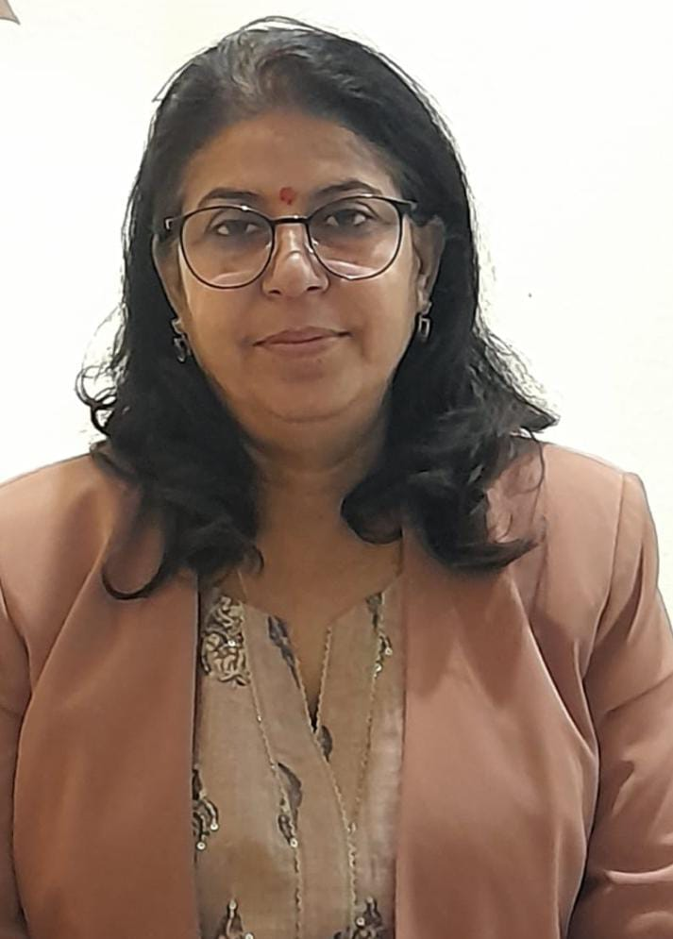  Color Photo
2 | Father’s/Husband Name | DR.AJAY KUMAR SINGH
3 | Date of Birth | 03/02/68
4 | Blood Group | O+ve
5 | Date of joining in College | 27/06/2003 | Date of Joining  As Teacher |  |  |  | 27/06/2003
6 | Designation | PROFESSOR
7 | Department | SANSKRIT
8 | Aadhar Number | 395008221864 |  | Pan No. |  |  |  | BAVPS9335L
9 | Specialization | SAHITYA
10 | Education Pursuit/Highest Qualification | PH.D.
11 | PhD/NET Passing Year and University Name: | 1993 –MAHATMA GANDHI KASHI VIDYAPITH ,VARANASI
12 | Are you recognized as research guides (Yes/No) if Yes when attached first registered Scholar letter | YES 2008-09
13 | Permanent Residential Address with District and State | BEHIND ROHTAS MAHILA COLLEGE, CIVIL LINES,SASARAM,ROHTAS ,BIHAR 821115
14 | Mobile No. | 9431828997 |  |  |  | VIDWAN ID : |  | 491248
15 | E-mail | SAVITRISINGH63@GMAIL.COM |  |  |  |  |  | Computer Knowledge (Yes/No) | YES
16 | Teaching Experiences: (in Year) | UG:21 |  |  | PG : |  |  | Total: 21
17 | Administrative Experience’s | 1)PROGRAMME OFFICER NSS  2)CTO NCC  3)U.R  4)OBSERVER (IGNOU,VKSU- UG EXAM)
18. Participation of teachers in various bodies of the Universities/Autonomous Colleges such as BoS and Academic Council, Evaluation, Question Setting etc.

Year | Name of the body in which full time teacher participated
2018-2019 | HEAD EXAMNER EVALUATION PART 2 AND 3
2019 | MEMBER OF SELECTION COMMITTEE AT KVS
19. Received awards, recognition, fellowships at State, National, International level from Government, recognized bodies.
Year of award | Name of the award, fellowship, received from Government or recognized bodies

20. Grants for research projects sponsored by the government/non-government sources such as UGC, industry, corporate houses, international bodies, endowments, Chairs in the institution.
Name of the research project/ endowment |  | Name of the Principal Investigator/Co-investigator | Department of Principal Investigator | Year of Award | Amount Sanctioned | Duration of the project |  | Name of the Funding Agency |  | Type (Government/non-Government)

21. Workshops/seminars conducted on Intellectual Property Rights (IPR) and Industry-Academia Innovative practices etc.
Year | Name of the workshop/ seminar | Date From – To | Link to the Activity report on the website | Date of establishment of IPR cell

22. The institution provides incentives or facility to teachers who receive state, national and international recognition/awards.
Name of the Awardee with contact details | Name of the Award | Name of the Awarding Agency | Year of Award | Incentive details

23. Give details of the Faculty Involvement in Active Research {Ph.D. Registered (RG), Submitted (SB) & Awarded (AW)}
SI.NO | NAME OF THE STUDENT | Gender | YEAR | TOPIC | STATUS (Tick)
 |  | M/F |  |  | RG | SB | AW
1 | NARAYAN OJHA | M | 2018 | PURANO MEIN DATTATREY EVAM ADHYATM YOG MEIN UNKA YOGDAN |  |  | √
2 | BIRENDRA KUMAR MISHRA | M | 2023 | SANSKRIT SAHITYA MEIN SHREE LAKSHMI KE SWAROOPON KA ADHYAN |  |  | √
3 | SURENDRA KUMAR GAUTAM | M | 2021 | BHATRIHARIKRIT SHATAKTRAYA MEIN VARNIT MANVIYE PRAVRITIYON KI ADHYATAN UPADEYTA: EK ANUSHEELAN | √

24. Research papers in the Journals notified on UGC Care list /other recognized agency.
Title of paper |  |  | Name of the author/s |  |  | Name of journal |  |  | Year of publication |  | ISBN/ISSN number
VIBHINN DHARMO KE DHARMIK SANHISRUTA KE LIYE PARAM SATTA E SWAROOPON KA SMANVYAY |  |  | DR. SAVITRI SINGH |  |  | AYAN |  |  | 2018 |  | 2347-4491-
BHAGWAT GITA MEIN NIHIT SHREE KRISHNA KE SANDESH EVAM UNKA MAHATVA |  |  | DR.SAVITRI SINGH |  |  | WORLD TRANSLATION |  |  | 2018 |  | 2278-0408
25. Books and chapters in edited volumes / books published.
Title of Book/Chapter Published |  |  | Title of the Paper |  |  | Year of Publication | ISBN/ISSN No. |  |  | Year of publication and Publisher |  | Affiliating Institution at the time of Publication
HARISHCHANDROPAKHYAN |  |  | DR.SAVITRI SINGH |  |  | HARISHCHANDROPAKHYAN | 2019 |  |  | 978-93-82329-42-8 |  | YUGANTAR PRAKASHAN DELHI 110093
26. Details of Papers presented in national/international conference-proceedings.
Title of the Paper |  |  | Title of the Proceedings of the Conference | Name of the Conference |  |  |  | Year of the Conference |  |  | Affiliating Institution at the time of Publication
SHREE KRISHNA KE UPDESHON KA SWAROOP EVAM SANSARIK JAN HETU UNKA MAHATAVA |  |  | SANSKRTI VANGMAY MEIN SHREE KRISHNA VIMARSH | INTERNATIONAL SANSKRIT CONFRENCE |  |  |  | 2019 |  |  | ALLAHABAD UNIVERSITY
SANSKRIT BHASHA KO SARVAKALIK, SARDESHIK MAHATVA PRADAN KARNE MEIN PARNNIYE VYAKARAN KA YOGDAN |  |  | PANNIYEAM MAHASHASTRAM SARVASHASTROPAKARKAM | INTERNATIONAL SANSKRIT SEMINAR |  |  |  | 2018 |  |  | B.H.U
VAIDIK VANGMAY MEIN URJA KI AWADHARNA |  |  | VEDIC VIGYAN-VAISHWIK ANUPRAYOG | INTERNATIONAL CONFERENCE |  |  |  | 2024 |  |  | B.H.U
27. Financial support to attend conferences / workshops and towards membership fee of professional bodies
Year |  | Name of conference/ workshop attended for which financial support provided |  |  | Name of the professional body for which membership fee is provided |  |  |  |  |  | Amount of support

28. Average percentage of teachers attending Faculty development Programmes (FDP), Management Development Programmes (MDPs) professional development /administrative training programs, viz., Orientation Program, Refresher Course, Short Term Course.
Year | Title of the FDP /MDP/ professional development / administrative training program | Date and Duration (from – to)

29. Details of the Life Membership academic societies, Editorial Board, if any others by the faculty member
SI.NO | Details Of Membership | Life Membership No. | If any Remarks

Note:
Please add extra sheets whenever required for extra information as well as provided information.
Please enclose all the documents, evidences, photographs, newspapers cutting regarding the information provided in above format at the time of submission.

DECLARATION
I hereby declare that all information furnished by me in this application is true to the best of my knowledge and belief.

Date:………………………………… Signature

